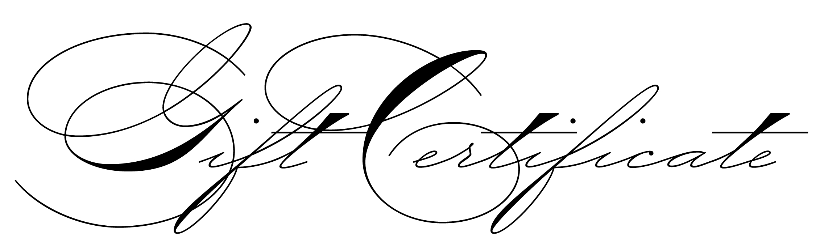
~From Natural Hormone Replacement
Clinics of Colorado~
12 hour cortisol stress test*
value: $25.00, transferable
*When used in combination with aN
All-in-one 11 Hormone** saliva lab panel ($399.00 value)
(**includes three estrogens, progesterone, melatonin, testosterone, dhea,
androstenadione, 17 hydroxy progesterone, Cortisol-14 hour)

must notify scheduling staff of the certificate

